**SVKM’s NMIMS**

**Mukesh Patel School of Technology Management & Engineering**

A.Y. 2022 - 23

**Course: Database Management Systems**

**Project Report**

| Program | BTech AI | |
| --- | --- | --- |
| Semester | 3rd | |
| Name of the Project: | Airport Management System | |
|  | | |
| Details of Project Members |  |  |
| Batch | Roll No. | Name |
| B1 | I028 | Aditya Kothari |
| B1 | I026 | Aditya Katariya |
| B1 | I020 | Aum Ghag |
| B1 | I018 | Urav Farooqui |
| Date of Submission: 16/10/2022 | | |

**Contribution of each project Members:**

| Roll No. | Name: | Contribution |
| --- | --- | --- |
| I028 | Aditya Kothari | Database creation, Data insertion, Python connectivity, GUI |
| I020 | Aum Ghag | Database creation |
| I018 | Urav Farooqui | Data entry |
| I026 | Aditya Katariya | Database creation, GUI |

**Note:**

1. Create a readme file if you have multiple files
2. All files must be properly named (I004_DBMSProject)
3. Submit all relevant files of your work ( Report, all SQL files, Any other files)
4. **Plagiarism is highly discouraged (Your report will be checked for plagiarism)**

**Rubrics for the Project evaluation:**

* Innovative Ideas and self learning (5 Marks) Idea should not be regular such as Hotel, Library Management system etc.
* Implementation and Design (10 Marks) It includes ER model, Relational model and Normalization of tables.
* Project Demonstration and Viva (5 Marks)

**Project Report**

**Airport Management System**

**by**

**Aditya Kothari, Roll number: I028**

**Aditya Katariya, Roll number: I026**

**Aum Ghag, Roll number: I020**

**Urav Farooqui, Roll number: I018**

**Course: DBMS**

**AY: 2022-23**

**Table of Contents**

| **Sr no.** | **Topic** | **Page no.** |
| --- | --- | --- |
| **1** | Storyline |  |
| **2** | Components of Database Design |  |
| **3** | Entity Relationship Diagram |  |
| **4** | Relational Model |  |
| **5** | Normalization |  |
| **6** | SQL Queries |  |
| **7** | Learning from the Project |  |
| **8** | Challenges you faced while doing the Project |  |
| **9** | Conclusion |  |

**I. Storyline**

This section should describe the requirements for the chosen database topic. Form a storyline and describe in detail.

The Project is a demonstration of Airport Internal Management System. This Database will be used by the Airport to store its internal information. This Database contains confidential information of the airport and is not open to the public eye. Our Database contains crucial information about the airlines, passengers, employees such as their unique id’s, their contact information. Airport management system using SQL is very helpful as it enables us to run specific queries that tells us about the database to fetch the desired information. With the Database we can generate customer specific information like ticket which depends on other tables and relations which makes ticket a weak entity.

With the integration of python, the frontend is pretty impressive. Our project simulates what a management system would look like at a larger scale. We can also add more tables and relations which would further enhance the database system. Our project at a pilot level is grand and industry ready.

**II. Components of Database Design**

Describe all entities along with their attributes here. Also, mention the primary keys for each entity.

Describe all relationships among various entities. Also, specify the cardinality and participation for all relationships.

The Database contains the following Tables:

**Relational Model**

1. PASSENGER
2. pass_passport_no [Primary Key]
3. pass_age
4. pass_name
5. AIRLINE:
6. airplane_id [Primary Key]
7. airline_manager
8. airline_model_no
9. airline_no_aircrafts
10. airline_no_employees
11. ARRIVALS:
12. airplane_id [Foreign Key]
13. arrival_time
14. arrival_location[Primary Key]
15. arrival_delay
16. DEPARTURES
17. airplane_id [Foreign Key]
18. depart_time
19. depart_delay
20. destination
21. TICKET:
22. seat_no
23. origin[Foreign Key]
24. destination[Foreign Key]
25. airplane_id[Foreign Key]
26. STORES:
27. store_id [Primary Key]
28. store_name
29. store_type
30. INTERNATIONAL:
31. pass_passport_no[Foreign Key]
32. inter_luggage
33. inter_immigration
34. airplane_id[Foreign Key]
35. destination[Foreign Key]
36. AIRCRAFT:
37. airplane_id [Foreign Key]
38. airline_model_no
39. airline_company
40. capacity
41. LOUNGE:
42. credit_card [Primary Key]
43. member_type
44. class_type
45. pass_passport_no[Foreign Key]
46. ASSISTANCE:
47. pass_passport_no [Foreign Key]
48. wheel_chair
49. golf_cart
50. caretaker
51. LUGGAGE:
52. luggage_id [Primary Key]
53. belt_no
54. pass_passport_no[Foreign Key]
55. PARKING:
56. vehicle_no [Primary Key]
57. parking_no
58. parking_time
59. DOMESTIC:
60. pass_passport_no [Foreign Key]
61. airplane_id[Foreign Key]
62. destination [Foreign Key]
63. origin
64. EMPLOYEE:
65. emp_id [Primary Key]
66. emp_name
67. emp_address
68. emp_phno
69. emp_salary

**III. Entity Relationship Diagram**

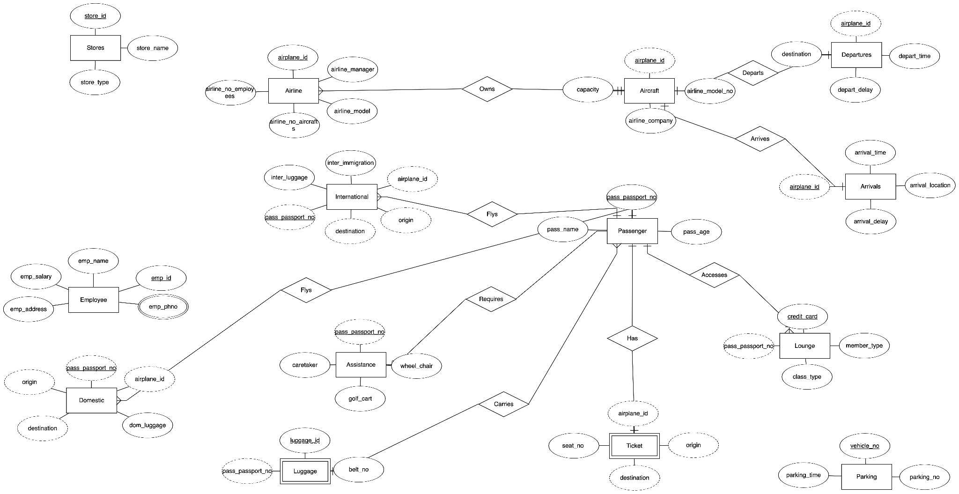

**V. Normalization**

All the tables are in 3NF as there are no partial or transitive dependencies.

**VI. SQL Queries**

* **Create the tables**

create database airport_management;

use airport_management;

CREATE TABLE IF NOT EXISTS PASSENGER (

PASS_NAME varchar(50) NOT NULL,

PASS_AGE int(2) NOT NULL,

PASS_PASSPORT_NO int(10) NOT NULL,

PRIMARY KEY (PASS_PASSPORT_NO));

CREATE TABLE IF NOT EXISTS AIRLINE (

AIRPLANE_ID VARCHAR(10),

AIRLINE_MANAGER VARCHAR(20),

AIRPLANE_MODEL_NO INT,

AIRLINE_NO_AIRCRAFTS INT,

AIRLINE_NO_OF_EMPLOYEES INT,

PRIMARY KEY (AIRPLANE_ID));

CREATE TABLE ARRIVALS(

AIRPLANE_ID VARCHAR(10),

ARRIVAL_TIME INT(10),

ARRIVAL_LOCATION VARCHAR(20),

ARRIVAL_DELAY INT(10),

PRIMARY KEY (ARRIVAL_LOCATION),

FOREIGN KEY (AIRPLANE_ID) REFERENCES AIRLINE (AIRPLANE_ID));

CREATE TABLE DEPARTURES (

AIRPLANE_ID VARCHAR (10) ,

DEPART_TIME INT,

DEPART_DELAY VARCHAR(10),

DESTINATION VARCHAR (20),

PRIMARY KEY(DESTINATION),

FOREIGN KEY(AIRPLANE_ID) REFERENCES AIRLINE (AIRPLANE_ID));

CREATE TABLE IF NOT EXISTS TICKET (

AIRPLANE_ID VARCHAR(10) ,

SEAT_NO int NOT NULL,

ORIGIN varchar(50) NOT NULL,

DESTINATION varchar(50) NOT NULL,

FOREIGN KEY (ORIGIN) REFERENCES ARRIVALS(ARRIVAL_LOCATION),

FOREIGN KEY (DESTINATION) REFERENCES DEPARTURES(DESTINATION),

FOREIGN KEY (AIRPLANE_ID) REFERENCES AIRLINE (AIRPLANE_ID));

CREATE TABLE STORES(

STORE_ID INT(15) PRIMARY KEY,

STORE_NAME VARCHAR(15),

STORE_TYPE VARCHAR(10));

* Populate the tables (insert some meaningful data, at least 10 tuples for each relation)

Data insertion was done using csv files

* Run SQL queries (minimum 15) covering **all concepts** learned in the class

select*from passenger

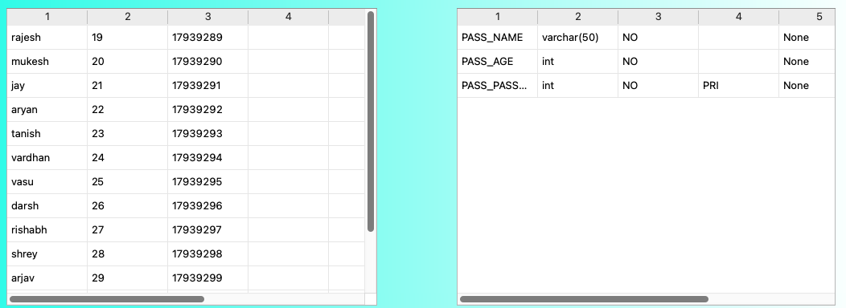

select*from passenger where pass_age=22

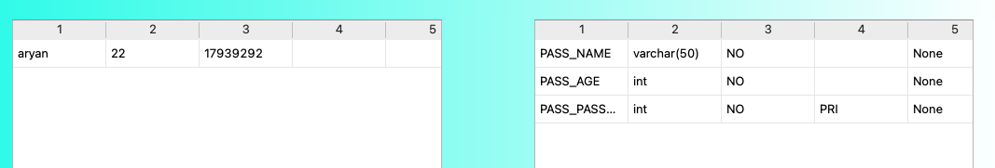

select*from passenger natural join luggage

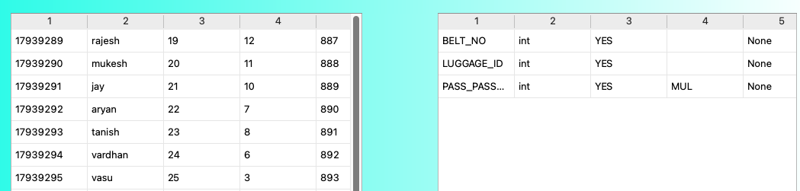

select*from stores

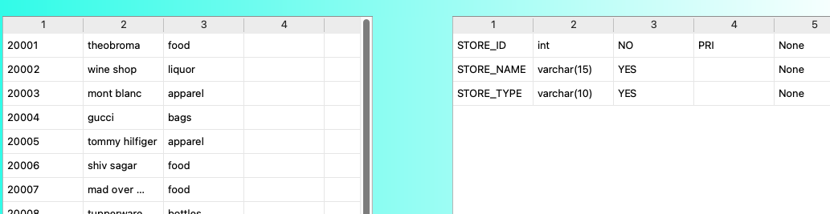

select*from stores where store_type='apparel'

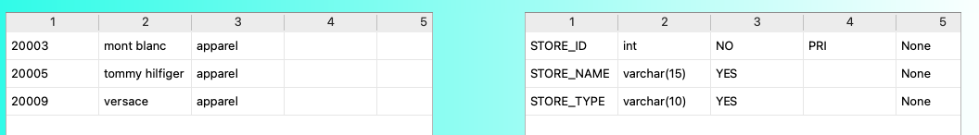

select*from assistance where golf_cart='Y'

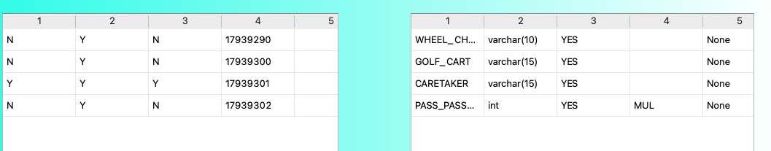

select*from airline natural join aircraft

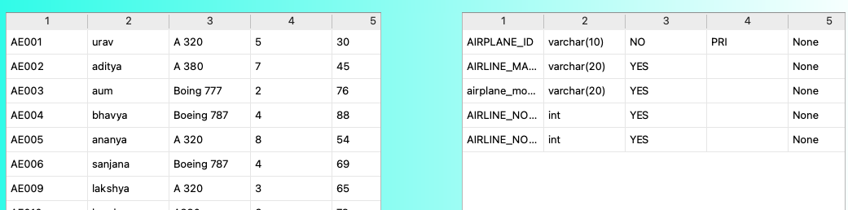

select*from lounge natural join international where member_type='gold'

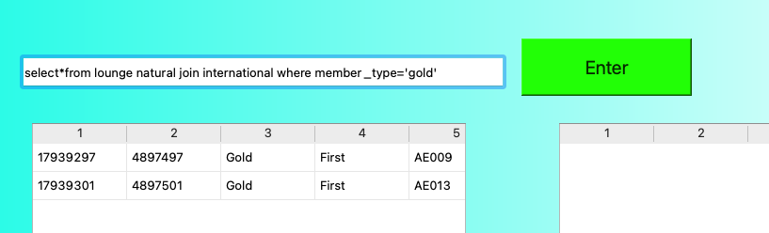

select pass_name from passenger where pass_passport_no in (select pass_passport_no from assistance where wheel_chair='Y')

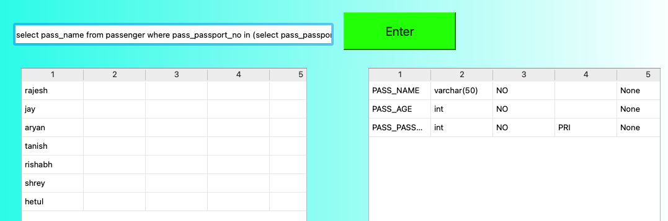

select count(luggage_id),belt_no from luggage group by belt_no

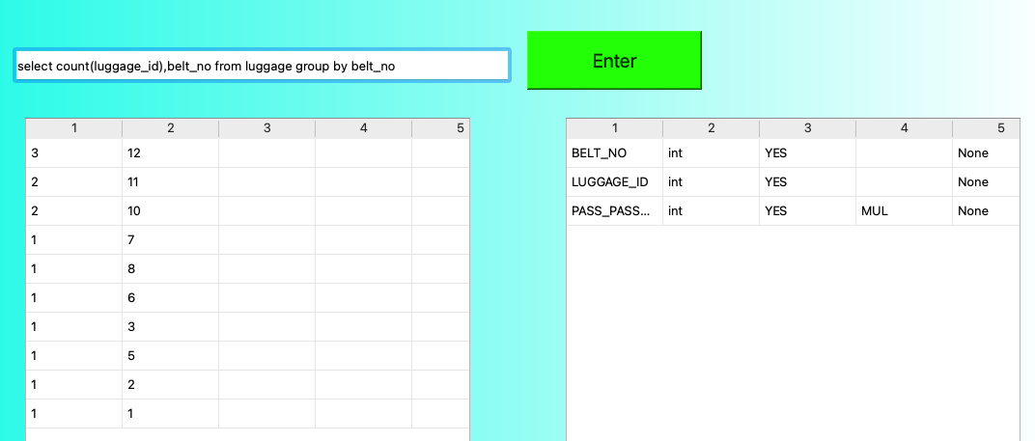

select count(vehicle_no),park_block from parking where park_time between 1120 and 1630 group by park_block

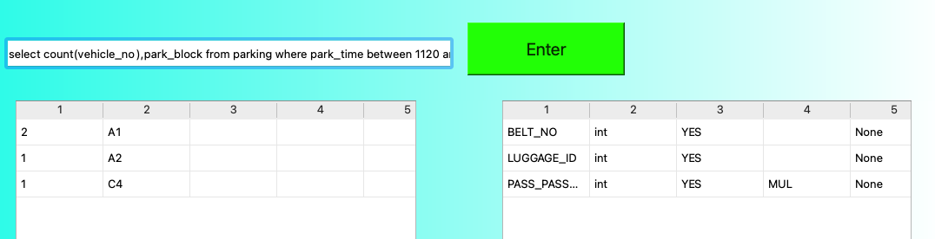

select*from passenger natural join lounge where member_type='Gold'

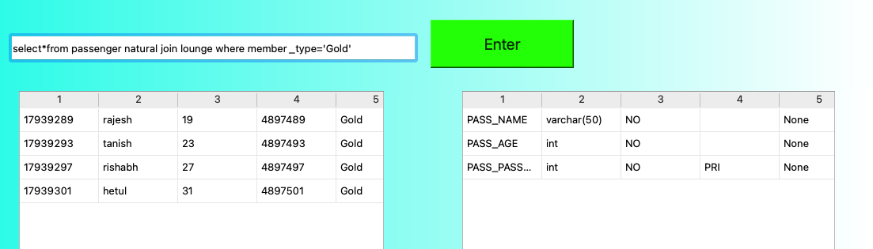

select*from employee where emp_salary>900

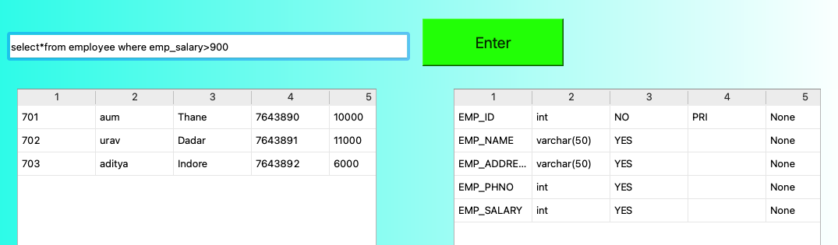

select airline_company, sum(capacity) from aircraft where airline_model like "Boeing%" group by airline_company

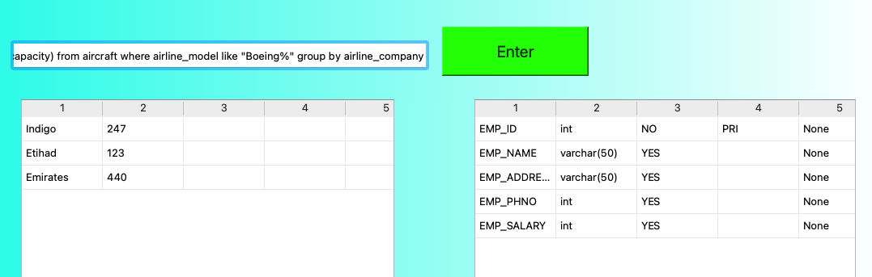

select * from aircraft,ticket where aircraft.airplane_id=ticket.airplane_id

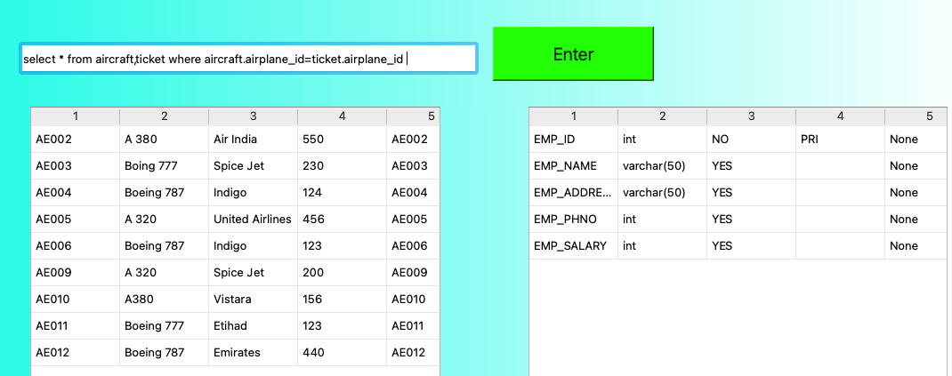

**VI. Project demonstration**

* Tools/software/ libraries used
* Screenshot and Description of the Demonstration of project ( If GUI is made)

Tools:

1. MySQL
2. Python

Software:

1. MySQL Workbench
2. PYcharm

Libraries:

1. Python:

* mysql.connector
* PyQt5
* sys
* 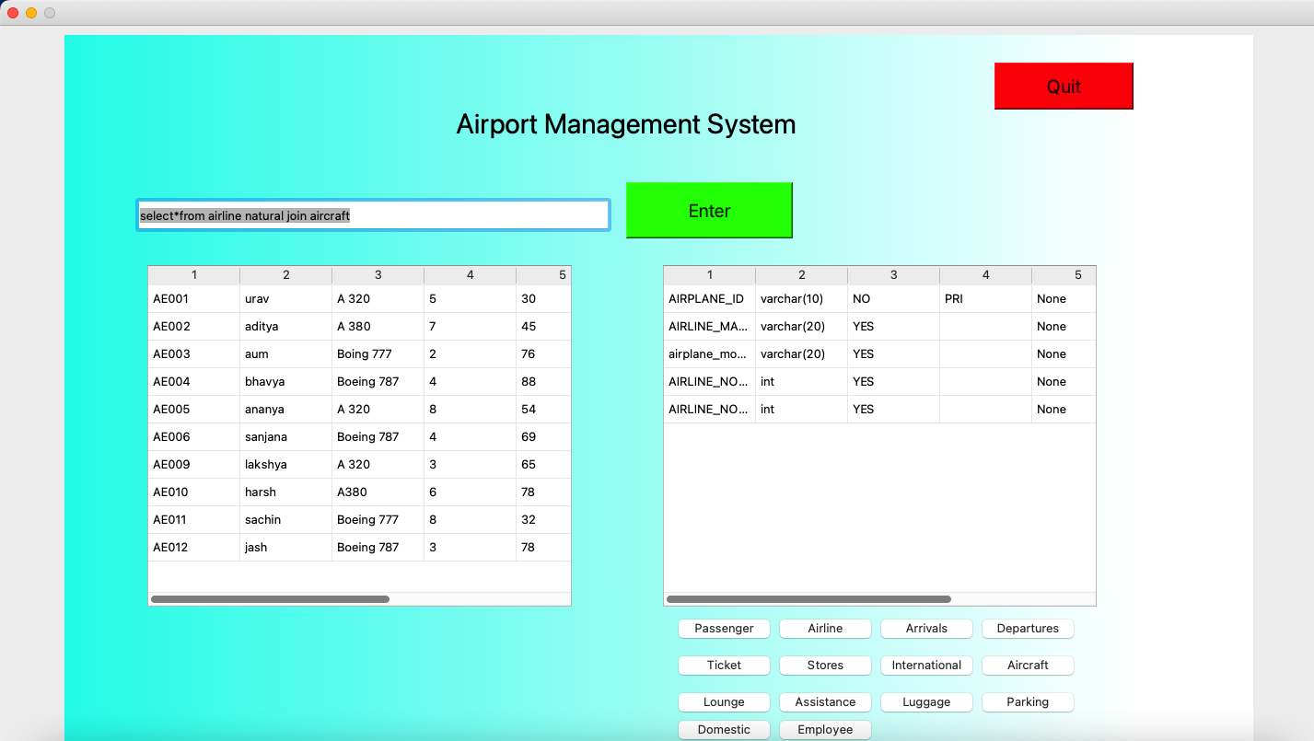

We’ve created an input box which will be used to take the input from the user and will execute after the user has pressed the “Enter” button. There are multiple buttons with the names of the entities which display the description of the respective entities. The quit button is used to exit the program.

**VII. Learning from the Project**

* How this project helped you?

This project really helped us understand the various concepts of Database Management Systems. We were able to implement every single thing which was taught to us in class. This project is built upon the ideas of each and every member of the group. All of our doubts and queries regarding MySQL were resolved after contributing towards this project.

* What new aspects did you learn?

One of the new things which we learnt is the infamous Python GUI. We learned the python library PyQt5 which enabled us to create fantastic new windows to help display our project in a more aesthetic way. We learned how to connect MySQL with Python which helped us understand various concepts of Object Oriented Programming because we created a separate function for each query in python.

These are a few techniques which we understood after completing this project.

**VIII. Challenges Faced**

The greatest challenge we faced was about Python GUI. For every query we had to create a separate function and a window, the placement of the keys and their execution.

We divided the queries amongst ourselves. We faced issues in the connection and the relation of the tables we created with primary and foreign keys.

**IX. Conclusion**

* What are the key takeaways from the project?

The key takeaways from this project was a broader and better understanding of MySQL, also to implement the learnings taken from the classroom. This project also helped us understand the relations and how the tables should be interrelated and how we can make the management system more efficient and reliable. Running the queries and getting the desired output was important for us to understand how the attributes interacted with each other, especially the primary and foreign keys; they played a salient role for the overall connectivity of the database.

We also learned about the relations used in real-life Airport management systems and how everything comes together, to make our project a replica of an actual Database management system. We also learned about Normalization and redundancies that may have caused additional problems for us, and how the anomalies could be eliminated. This project was very crucial for our understanding and implementation of SQL in real-life and beyond. Our project also helped us to learn more about the Python GUI which is an important language for our current course. The interaction between the frontend and backend gave us a broader understanding of the two languages and their connection with each other.